Fed Cup by BNP Paribas

Play off 2017 World Group B

Serbia v Australia
Hala “Kristalna Dvorana” Zrenjanin
Saturday 22 – Sunday 23 April 2017
MEDIA ACCREDITATION APPLICATION FORM

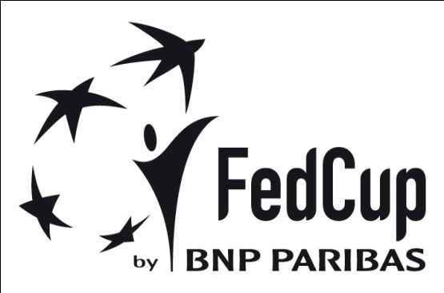

Deadline for Media Accreditation – Wednesday 18 April 2017

Media Organisation

Address

Country Postal Code

Emai

Telephone Fax

Name of applicant (family name) (first name)

Category

Writer Radio Photographer TV

Type
Daily newspaper Weekly newspaper Magazine Agency

Other ____________

Any individual requirements: (Radio position, TV...)
Deadline for Media Accreditation
Please send your accreditation form until 18. 04. 2017. to the:
E-mail: akreditacijetss@yahoo.com
Fax: +38111 7121899
Mob. +38164 6401204 PR STF Neda Miletic
For every journalist we will have a desk space in the media work area.

There will be free WiFi in the media work area.
We need a photo for accreditation.

