PRVENSTVO SRBIJE
LIVE STREAM

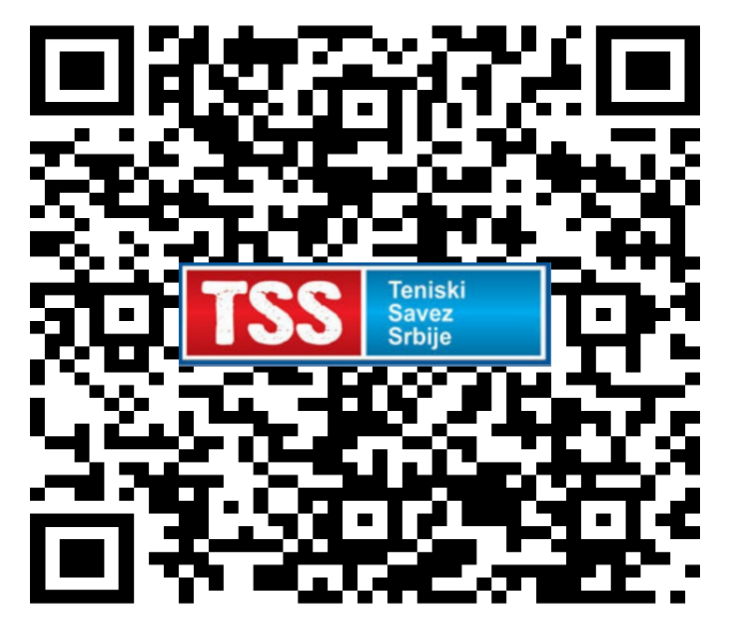
https://www.youtube.com/channel/UCa85irGVKGmM4HQzmK7GW1Q/videos

