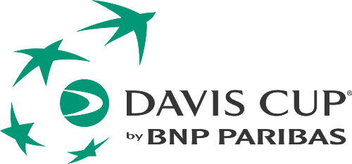
Davis Cup by BNP Paribas

2016 World Group Quarterfinal

Serbia v Great Britain
Tasmajdan Stadium, Belgrade
Friday 15 – Sunday 17 July 2016
MEDIA ACCREDITATION APPLICATION FORM

Deadline for Media Accreditation – Wednesday 01 July 2016

Media Organisation

Address

Country Postal Code

Emai

Telephone Fax

Name of applicant (family name) (first name)

Category

Writer Radio Photographer TV

Type
Daily newspaper Weekly newspaper Magazine Agency

Other ____________

Any individual requirements: (Radio position, TV...)

Deadline for Media Accreditation
Please send your accreditation form until 01. 07. 2016. to the:

E-mail: akreditacijetss@yahoo.com
Fax: +38111 7121899
Mob. +38164 6401204 PR STF Neda Miletic
For every journalist we will have a desk space in the media work area.

There will be free WiFi in the media work area.

We need a photo for accreditation.

Media hotel information:

Name: Hotel Constantine the Great Belgrade
Address: Constantine the Great d.o.o.
27 Marta 12, 11000 Belgrade, Serbia

Rate: EUR 67 single room per night, including breakfast and wifi internet
+ local tax 1,2 EUR per day
EUR 77 double room per night, including breakfast and wifi internet +
local tax 1,2 EUR per day
Contact for booking: Milica Neskovic 00381 60 8898336, email:
milica.neskovic@hotel-constantine.com

http://www.constantinethegreatbelgrade.com/hotel/en

Deadline for booking: 10 June 2016

