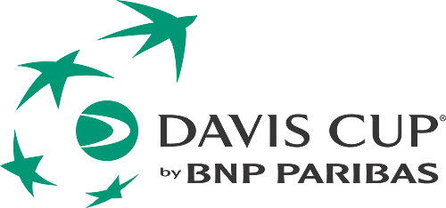
Davis Cup by BNP Paribas

2017 World Group 1st round

Serbia v Russia
Hala Cair, Niš
Friday 3 – Sunday 5 February 2017
MEDIA ACCREDITATION APPLICATION FORM

Deadline for Media Accreditation – Friday 20 January 2017

Media Organisation

Address

Country Postal Code

Emai

Telephone Fax

Name of applicant (family name) (first name)

Category

Writer Radio Photographer TV

Type
Daily newspaper Weekly newspaper Magazine Agency

Other ____________

Any individual requirements: (Radio position, TV...)

Deadline for Media Accreditation
Please send your accreditation form until 20. 01. 2017. to the:

E-mail: akreditacijetss@yahoo.com
Fax: +38111 7121899
Mob. +38164 6401204 PR STF Neda Miletic
For every journalist we will have a desk space in the media work area.

There will be free WiFi in the media work area.

We need a photo for accreditation.

Media hotel information:

Name: Hotel The Regent Club
Address: Gen. Milojka Lešjanina 7a
18000 Niš SERBIA

Rate: EUR 30 single room per night, including breakfast, wifi internet
and local tax
EUR 37 double room per night, including breakfast, wifi internet and
local tax
+ parking facilities

Contact for booking: Jovana Tonić
The Regent Club Generala Milojka Lešjanina 7a
18000 Niš SERBIA
Tel. +381 18 524 924
Fax. +381 18 524 520
Cel. +381 60 064 18 15
recepcija@regentclub.com
www.regentclub.com

Deadline for booking: 20 January 2017

